

NAME: AJAY KUMAR REDDY
REG NO:192425274
COURSE CODE: MLA0214
COURSE NAME: FUNDAMENTAL OF MACHINE LEARNING

QUESTION: Write a program to implement Naïve Bayes algorithm in python and to display the results using confusion matrix and accuracy.
AIM: To implement the Naïve Bayes algorithm and evaluate performance using confusion matrix and accuracy.
ALGORITHM:
- Start the program.
- Define the dataset.
- Train the Naïve Bayes model.
- Predict outputs.
- Generate confusion matrix.
- Calculate accuracy.
- Display results.

CODE:
from sklearn.naive_bayes import GaussianNB
from sklearn.metrics import confusion_matrix,accuracy_score

X = [[1],[2],[3],[6],[7],[8]]
y = [0,0,0,1,1,1]
model = GaussianNB()
model.fit(X,y)
pred = model.predict(X)
print("Confusion Matrix:")
print(confusion_matrix(y,pred))
print("Accuracy:")
print(accuracy_score(y,pred))
OUTPUT:
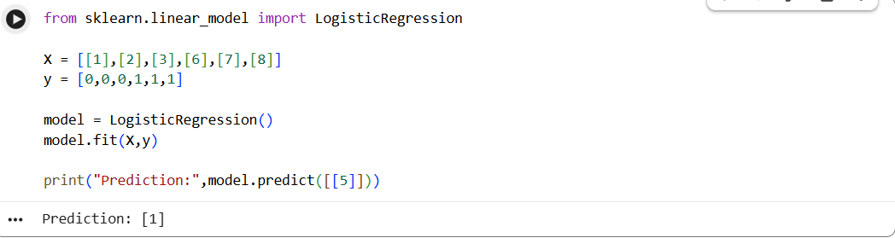
RESULT:
The Naïve Bayes classifier successfully predicts classes and displays the confusion matrix and accuracy.

